**Data Science question Bank**

**1. Write a Python program to create a NumPy array of shape (3,4) filled with random integers between 1 and 100.**

**2.Implement a Python program that performs the following NumPy operations:**

* **Joins two arrays**
* **Splits an array into three parts and Sorts an array in ascending order**

Ans – 1

Ans – 2

**3.Given two NumPy arrays, A = np.array([1, 2, 3]) and B = np.array([4, 5, 6]), perform the following operations:**

* **Element-wise addition**
* **Element-wise multiplication**
* **Dot product**

Ans –

**4. Write a Pandas program that:**

* **Reads a dataset and Selects specific columns**
* **Filters rows based on a condition**
* **Sorts the DataFrame based on a column**

****

**5.Write a program to sort a NumPy array along both rows and columns.**

Ans –

**6. Describe about array slicing and do the following: (1 mark)**

**a)Given the array arr = np.array([10, 20, 30, 40, 50, 60, 70, 80]), extract elements from index**

**2 to 5**

**b) Negative Slicing: extract elements from index -2 to -5**

**Ans –**

**7.Create a Pandas Series with custom index labels ['A', 'B', 'C', 'D', 'E'] and values [10, 20, 30, 40, 50]. Retrieve the element at index "C".**

Ans –

**8. Illustrate on column operations in pandas data frame with an example**

Ans –

**9. Discuss in detail about stacking and its types. Justify how it is differentiated with an example**

**Ans -** Stacking is a process of reshaping a DataFrame by converting columns into rows or vice versa. It is mainly used for data transformation and is classified into two types:

Stacking (Row-wise Stacking)

Unstacking (Column-wise Stacking)

1. Stacking (Row-wise Stacking)

* Moves the columns into a hierarchical row index.
* Converts a wide DataFrame into a long format.
* Achieved using .stack().

2. Unstacking (Column-wise Stacking)

* Moves the row index into columns.
* Converts a long DataFrame into a wide format.
* Achieved using .unstack().

*Example –*

**10.Create a multi-index DataFrame where the first level of the index represents Departments (IT, HR, Finance) and the second level represents Employee IDs (101, 102, 103). Assign random salaries and display the DataFrame.**

--Output

#### 11.(a) Create a DataFrame with the following data and display it. (2 Marks)

| **Name** | **Age** | **Score** |
| --- | --- | --- |
| **David** | **21** | **78** |
| **Emma** | **25** | **92** |
| **Frank** | **22** | **85** |

**(b) Select and display the "Score" column and retrieve the row where the Name is "Emma". (2 Marks)**

**(c) From the DataFrame, filter students who scored more than 80 and sort them by Age in descending order. (2 Marks)**

**(d) Assign performance levels based on the scores using the following criteria: (4 Marks)**

* **Score ≥ 90 → "Excellent"**
* **Score ≥ 80 and < 90 → "Good"**
* **Score < 80 → "Needs Improvement"**

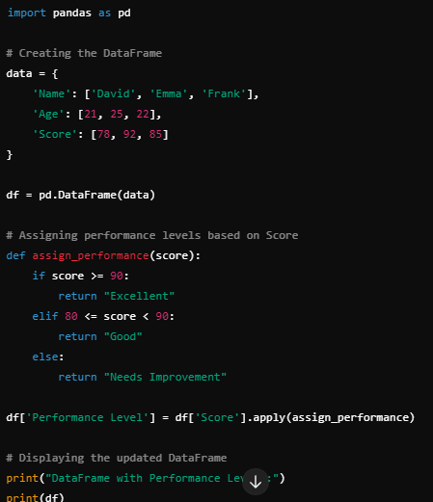

**12. What is the difference between vstack() and hstack()?**

**13. Given an array of shape (4,4), split it into two equal halves and then stack them back together.**

**14. Explain about Stacking and Unstacking in DataFrames.**

Stacking and unstacking are two operations in pandas DataFrames that help reshape data by pivoting between wide and long formats. They’re particularly useful when dealing with multi-level indices or when you need to reorganize data for analysis or visualization. Let me break it down for you.

**Stacking**

Stacking takes a DataFrame and "compresses" columns into rows, effectively pivoting column labels into an additional index level. This transforms a wide DataFrame into a taller, narrower one. It’s like stacking the columns on top of each other.

For example, imagine you have a DataFrame like this:

The columns 'A' and 'B' became part of a MultiIndex along with the original index ('x' and 'y'), and the values got aligned accordingly. The result is a Series with two levels of indexing. You can think of it as "melting" the columns into rows.

**Unstacking**

Unstacking does the opposite—it takes a level of the index and "spreads" it back out into columns, turning a tall DataFrame (or Series) into a wider one. It’s like unstacking the rows back into a grid.

Using the stacked Series from above:

Here, .unstack() took the innermost index level (the one with 'A' and 'B') and turned it back into columns, reconstructing the original DataFrame. You can also specify which level to unstack if you have a MultiIndex with more than two levels.

** **